Assignment 3

Marks for Assignment 3 total 80 (10 marks for each question).
1. Draw Lewis structures for each of the following species.
a. Ca3(PO4)2
b. N2O4 (all oxygen atoms are terminal)
c. C2H4O
d. ClO2– (Cl is the central atom)
e. SCl6

2. Use the VSEPR method to predict the molecular shape of the following species. Show all your reasoning.
a. CO32 –
b. CHCl3
c. IO2F2–
d. IF4–
e. OCS
f. PCl3
g. BrF3

3. a. Arrange the following bonds in order of increasing percent ionic character: Li—F, K—O, N—N, S—O, and Cl—F.
b. Calculate the lattice energy for solid CaBr2 from the following information:
• the heat of sublimation of Ca is 121 kJ/mol
• the first ionization energy for Ca is 590 kJ/mol
• the second ionization energy for Ca is 1145 kJ/mol
• the heat of vaporization for liquid Br2 is 315 kJ/mol (the standard state of bromine is as a liquid)
• the bond dissociation energy for gaseous Br2 is 193 kJ/mol
• the electron affinity for gaseous bromine atoms is –324 kJ/mol
• the overall heat of formation of solid CaBr2 is –675 kJ/mol

4. Use the VSEPR or the hybridization method to predict the bond angles in the following molecules. Show your reasoning.
a. SO2
b. SO3
c. SO32-
d. SO42–
e. SF4
f. SF6
g. SF2

5. Deduce the hybrid orbitals used by nitrogen atoms in the following species. Give your reasons.
a. NH3
b. H2N—NH2
c. NO3–
d. HCN
e. N2
f. NNO

6. a. The CN molecule has been observed spectroscopically in comets where pressure has been estimated to be as low as 10–10 mm Hg. Draw a Lewis structure for CN. Suggest an explanation as to why this species can persist in a comet but is unstable under normal terrestrial conditions.
b. Draw a Lewis structure for the diimide molecule, N2H2. Which bonds in this molecule are σ and which are π? Explain how π bonds are formed during orbital overlap.

7. a. The structure of 1,3-butadiene is usually written as H2C=CH–CH=CH2. The average bond lengths given in Table 9.2 in your textbook are: C–C of 154 pm and C=C of 133 pm. Explain the fact that the observed value of the distance between the two central carbon atoms in 1,3-butadiene is 146 pm.
b. 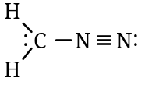 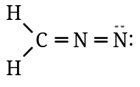 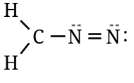
(i) (ii) (iii)
Which of the above three possible resonance structures would make the greatest contribution to the resonance hybrid? Explain your answer.
c. Cinnamaldehyde (structure given below) gives the spice cinnamon its characteristic odour. How many sigma (σ) bonds and how many pi (π) bonds are in this molecule?
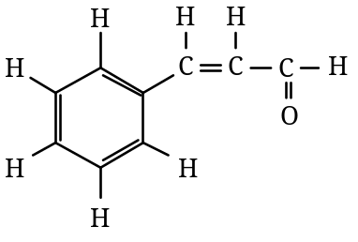 cinnamaldehyde

8. Which of the following species have a zero reading for dipole moment? Give brief reasons for your answers, dealing with each species separately.
a. BrF3
b. CH2F2
c. CO
d. CO2
e. OF2
f. XeF4

